**CST8256 Web Programming Language I**

**Lab 1**

**Objective**

1. Review C# and ASP.NET learnt in course CST8253.

**Due Date**

See Brightspace posting for the due date. To earn 5 points, you are required:

1. Complete the lab as required.
2. Zip your **website folder** and submit to the Brightspace before the due date.
3. Demonstrate your lab work during the following week’s lab session(s).

**Instructions**

* Download Lab 1.zip from Canvas
* Unzip the file to get a partially implemented website **Lab 1**.
* Complete the implementation of the website to satisfy the requirements listed in the Requirements Section below.
* You can open the Website “Lab 1” in Visual Studio by selecting menu item “File > Open > Web Site …” and then selecting the folder containing the Website “Lab 1” in the “Open Web Site” dialog.

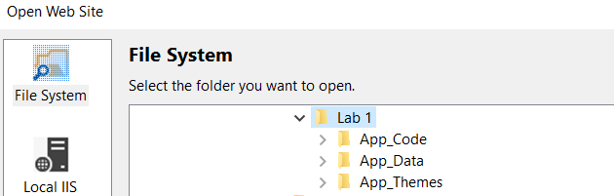

* All necessary entity classes and data access classes have been fully implemented. Study and understand the functionality of these classes.
* The ASPX web pages **BookStore.aspx** and **ShoppingCartView.aspx** have been fully implemented **except** the required validator controls, indicated by

<% -- **todo**: --%>

* **BookStore.aspx.cs** and **ShoppingCartView.aspx.cs** are partially implemented. The missing parts are all indicated by **todo**: comments. You can view all **todo**s in the Task List View by select menu item **View > Task List**

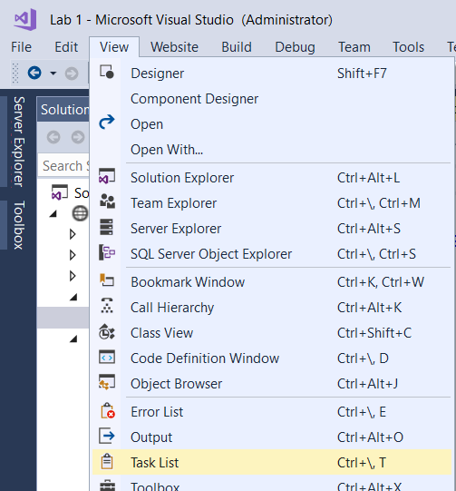

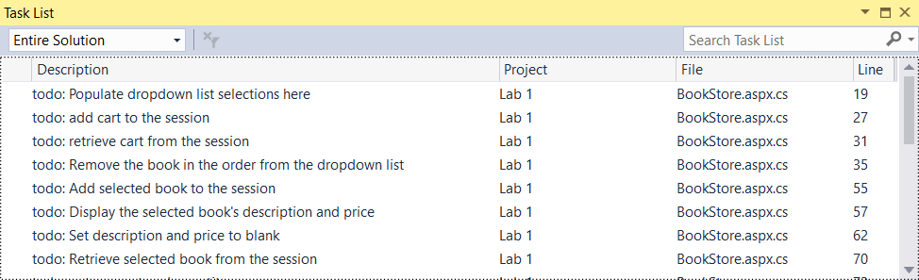

**Requirements**

1. This website has two pages BookStore.aspx and ShoppingCartView.aspx. The start page, BookStore.aspx, displays the following elements:
   1. A dropdown list control, initially displays “Select a Book …”
   2. In the dropdown of the dropdown list control, it lists all books available for the user to select.
   3. A text box for the user to enter the Quantity (number of copies) of the selected book to buy.
   4. An **Add to Cart** button for the user to add the selected book and the specified quantity to a shopping cart.
   5. A **View Cart** link navigating the user to **ShoppingCartView.aspx** page.

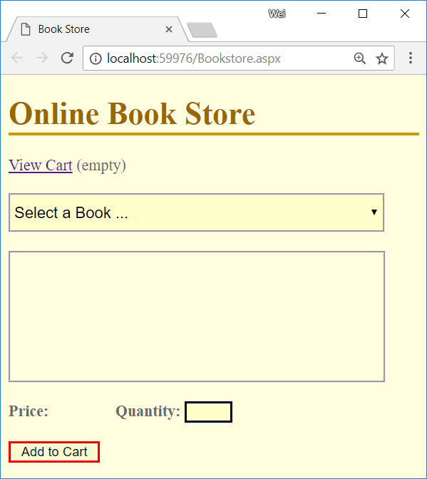

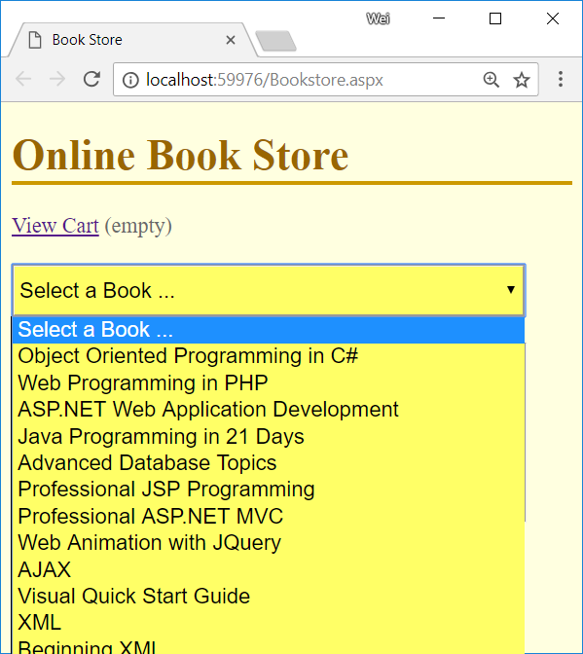

1. This page should have the following behaviors:
   1. To proceed, the user must select a book from the dropdown list and enter a number from 1 – 3 in **Quantity** text box. Otherwise appropriate error messages will be displayed as shown below:

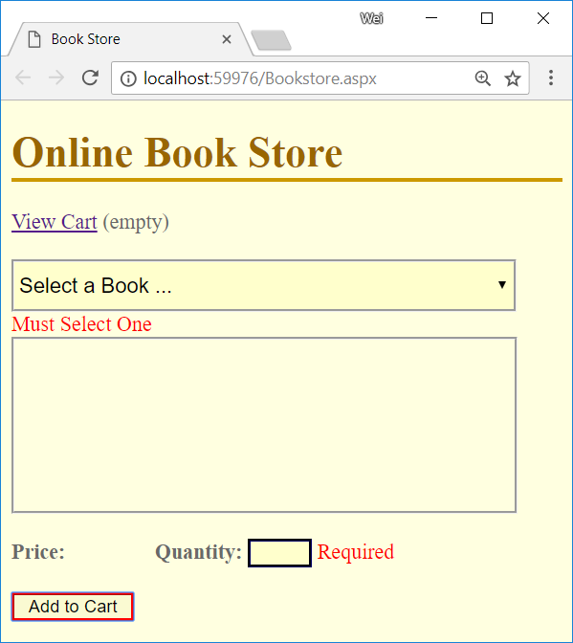

* 1. Once the user selected a book from the dropdown list, the page displays:
     1. the book’s description in the Description area
     2. the book’s price next to the Price label.

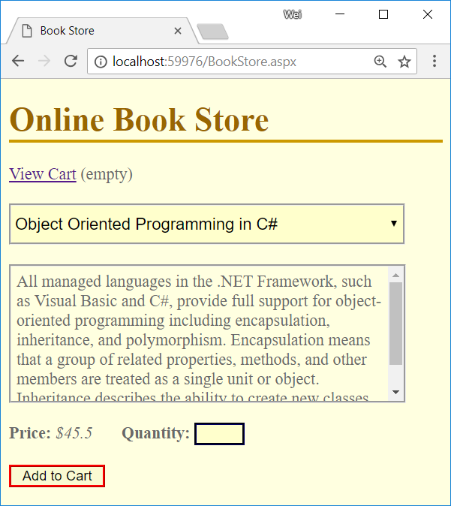

* 1. The user selected a book from the dropdown list and entered a valid number of copies to buy in the Quantity box and clicked “Add to Cart” button:
     1. The page confirms the selected book and the number of the specified copies are added to the shopping cart in the description area.
     2. The text in the **View Cart** link is updated with the current number of items (each book added into the cart is counted as one item regardless the quantity) in the shopping cart.
     3. The selected book is removed from the dropdown list so that the user will not be able to select the same book again.
     4. The dropdown list displays its initial text “Select a Book …”

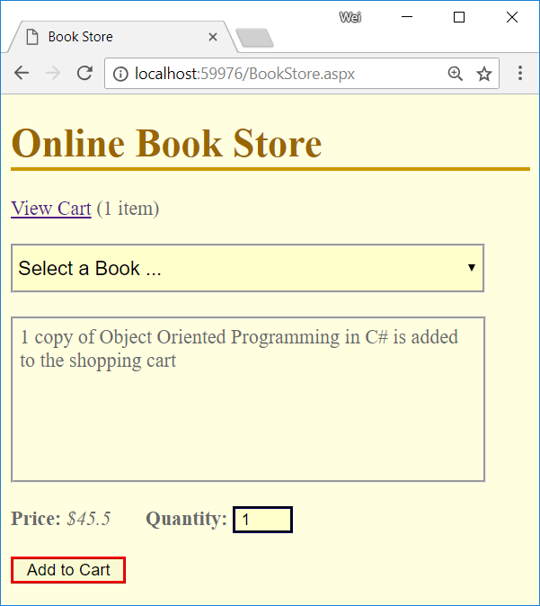

1. When the user clicks the **View Cart** link, the page displays the contents of the shopping cart.
   1. If the user has not added any book to the shopping cart, the page displays that the shopping cart is empty.

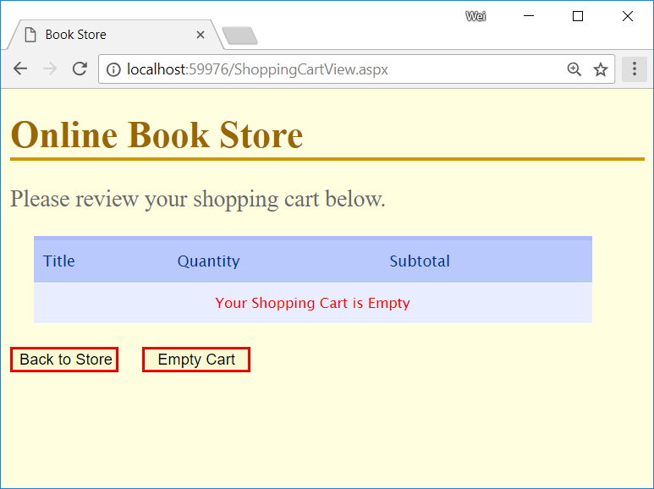

* 1. Otherwise, for each book the user placed in the shopping cart, the page displays the book tittle, the quantity of the book(s) the user added to the shop cart and the subtotal (quantity x price) of the selected book.
  2. The page also shows the total amount payable of the shopping cart.

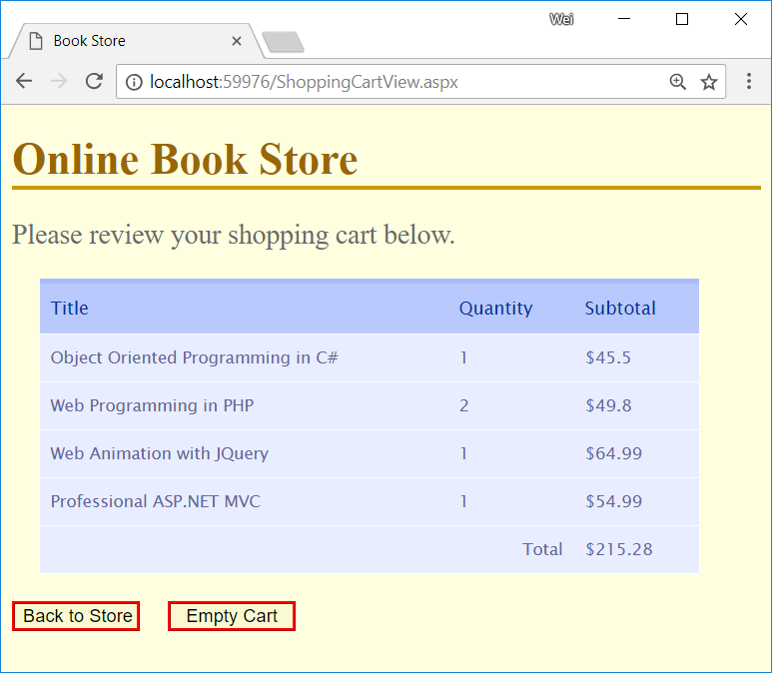

1. The page **ShoppingCartView.aspx** also contains two buttons:
   1. **Back to Store** button, this button brings the user back to the Book Store page so that the user can add more books to the shopping cart.

Note: the books already in the shopping cart should not be displayed in the book selection dropdown list.

* 1. **Empty Cart** button, this button allows the user to remove all books from the shopping cart. Once clicked the page will show empty shopping cart:

